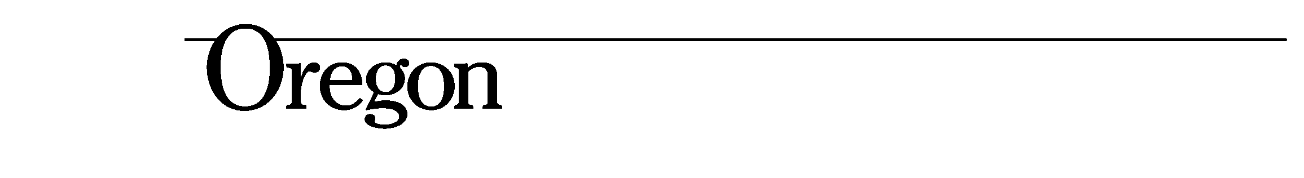

John A. Kitzhaber, MD, Governor

State Library
250 Winter St. NE
Salem, OR 97301-3950
(503) 378-4367
FAX (503) 585-8059

Progress Report on Oregon State Library Transformation
MaryKay Dahlgreen
September 24, 2013

The State Library and the Department of Administrative Services, Office of the Chief Operating Officer appeared before the General Government Subcommittee of the Interim Joint Ways & Means Committee on September 17th to provide an interim report on the progress of the OSL transformation.

Much work has been done by the project team and work groups in preparation for the report that was submitted to the subcommittee in August. Additionally, there has been collection of data and recommendations in this general topic area for several years – including the Envision Oregon 2009 report, the Feb 2012 Report on State Library, State Law Library and State Archives.

There were many conversations leading up to the hearing which included the Secretary of State’s office and the Judicial branch. Those conversations led to the understanding that the transformation process would be unable to move forward without some clear legislative direction – not just to the State Library but to the other agencies involved.

At the hearing, Senator Steiner-Hayward and Representative Nathanson agreed to take the lead on drafting a letter to the State Library, the Secretary of State, the Judicial Branch, and the Oregon Historical Society which would provide clear direction for the desired end state of many services currently delivered by the State Library. Our understanding is that the process that will be used to finalize that direction will consider the authorizing statutes for the State Library, the Secretary of State, and the Judicial Branch as it relates to services currently provided by OSL. A series of meetings are being scheduled this week with all parties to gather their input and feedback directly.

Once a letter is issued to all parties giving direction, we anticipate that DAS will be asked to facilitate cross-agency implementation planning effort(s) to make the desired changes. We expect the letter to be delivered on October 15th or 16th to all parties involved.

